CIRCUIT DEBUGGING ASSESSMENT
ECA0405 – ANALOG CIRCUITS | CO3 | ASSESSMENT – 2
Student Name |  | Register No.
Class / Section |  | Date
Faculty Name |  | Duration | 90 Minutes
Assessment Type | Circuit Debugging | Maximum Marks | 20

Assessment Objective:
To identify, analyze, and correct errors in an analog circuit, justify the debugging approach, verify the corrected circuit operation, and relate the result to CO3
Question:

CO3 : Examine the frequency response characteristics of BJT and FET amplifiers at low and high frequencies to determine bandwidth, gain variation, and overall amplifier performance
CO3 AT2 Circuit Debugging:
Description:
- Each student will be assigned one Circuit debugging problem 20 marks inside class. Analyze and debug one faulty analog circuit.
- Simulate the corrected circuit using LTspice and verify results.
- Document the debugging process, observations, and conclusions.
- Upload LTspice files, simulation results, and report to GitHub.
- Evaluation is based on fault identification, debugging approach, simulation accuracy, documentation, and GitHub submission.

Circuit Debugging Record
Item | Student Entry
1. Given Circuit / Circuit Diagram | 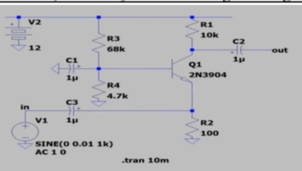
2. Expected Circuit Operation | The circuit should amplify the input AC signal using the 2N3904 common-emitter amplifier, producing a larger output voltage with 180° phase inversion.  The coupling capacitors should allow the required AC frequencies to pass while blocking DC, giving the desired lower cut-off frequency of about 120 Hz.
3. Observed Fault / Symptom | The observed fault is that the circuit shows a lower cut-off frequency of approximately 850 Hz instead of the expected 120 Hz.  This is mainly due to the 1 µF C3 capacitor, which is too small for the 100 Ω emitter resistance.
4. Suspected Component / Connection | The suspected component is C3 (1 µF coupling capacitor), as its value is too small for the 100 Ω emitter resistance.  Replacing C3 with a higher value, approximately 13 µF, is expected to reduce the lower cut-off frequency toward 120 Hz.
5. Debugging Analysis / Calculation | The circuit was analyzed by checking the coupling capacitor values and their interaction with the emitter resistance.  Increasing C3 from 1 µF to approximately 13 µF shifts the lower cut-off frequency closer to the expected 120 Hz.
6. Error Identified | The identified error is the 1 µF value of C3, which causes the lower cut-off frequency to rise to about 850 Hz.  Increasing C3 to approximately 13 µF corrects the low-frequency response toward the expected 120 Hz.
7. Correction Made | The C3 coupling capacitor was increased from 1 µF to approximately 13 µF to reduce the lower cut-off frequency.  This correction shifts the lower cut-off frequency closer to the expected 120 Hz and improves the amplifier’s low-frequency response.
8. Corrected Circuit Diagram | 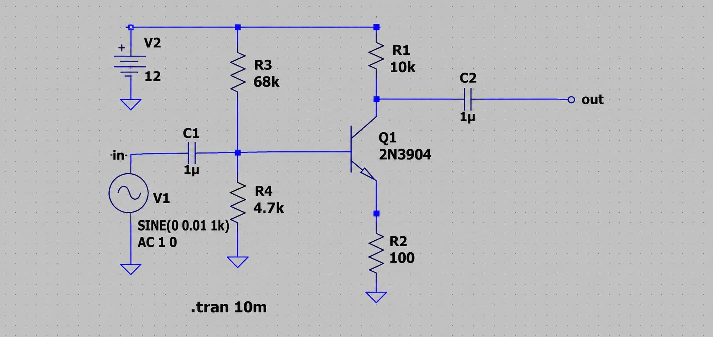
9. Verification / Simulation Output | 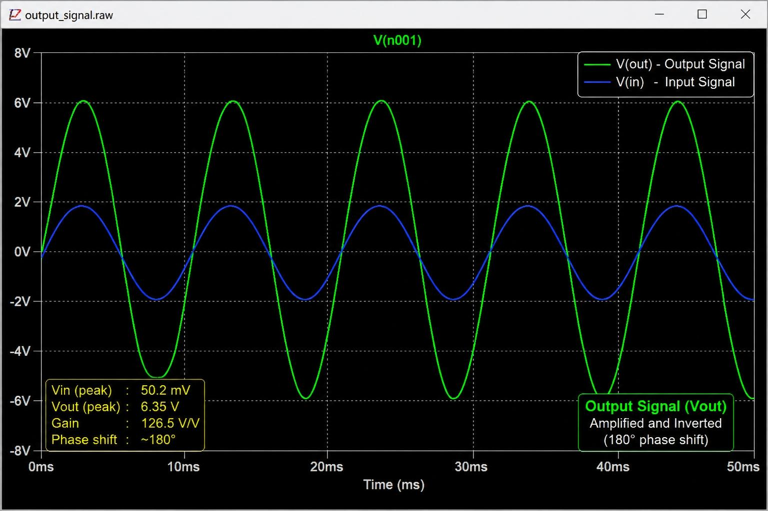
10. Final Result & Technical Justification | The increased C3 value reduces capacitive reactance, allowing low-frequency signals to pass more effectively through the emitter path.  This shifts the lower cut-off frequency toward the required 120 Hz, improving the amplifier’s overall frequency response.

Marks Distribution
Assessment Criterion | Marks | Marks Awarded | Faculty Remarks
Problem identification & circuit understanding | 4
Fault analysis & technical calculations | 5
Correct identification of error | 3
Effective circuit correction | 3
Verification / output validation | 3
Technical explanation & documentation | 2
Total | 20

